Day 30 - 104608492 - Shirisha Perapagu

AWS DynamoDB – part 2

Task01

Create a table using AWS Management Console

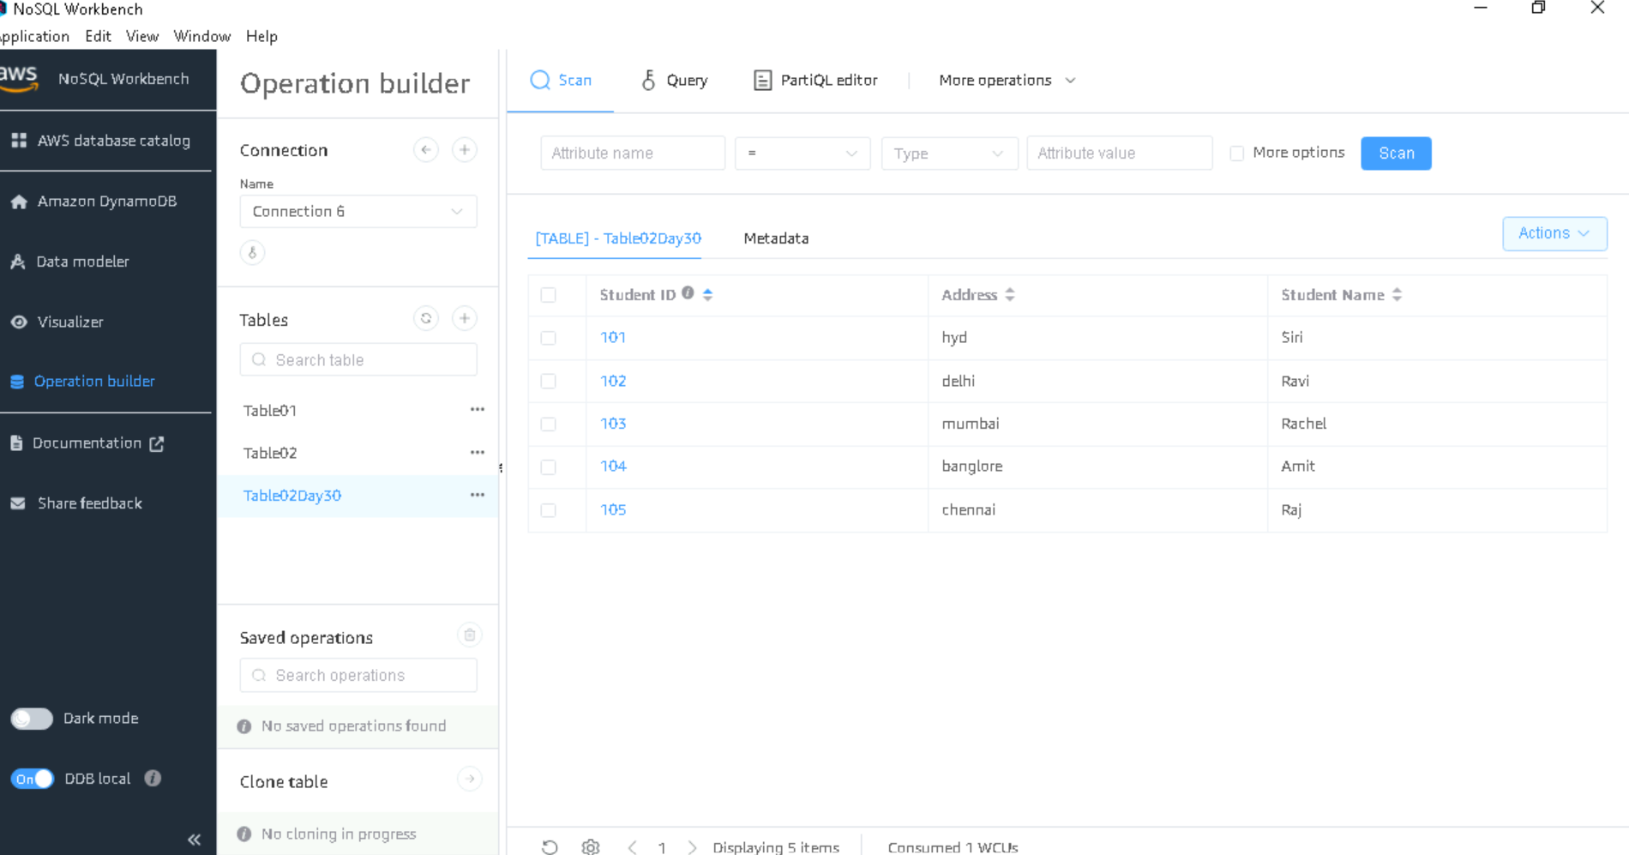

Task02

Use all the CRUD operations using AWS Management Console.

1. Create item with PartitionKey 111

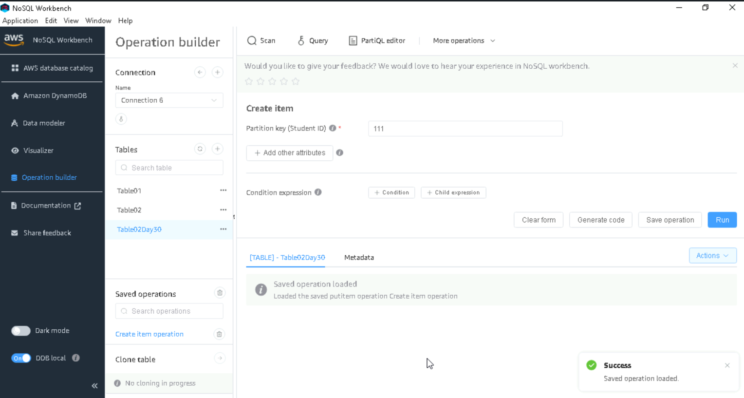

1. Update item for partition key 111

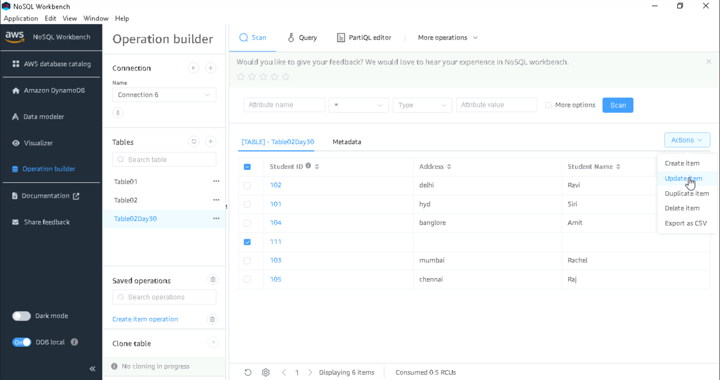

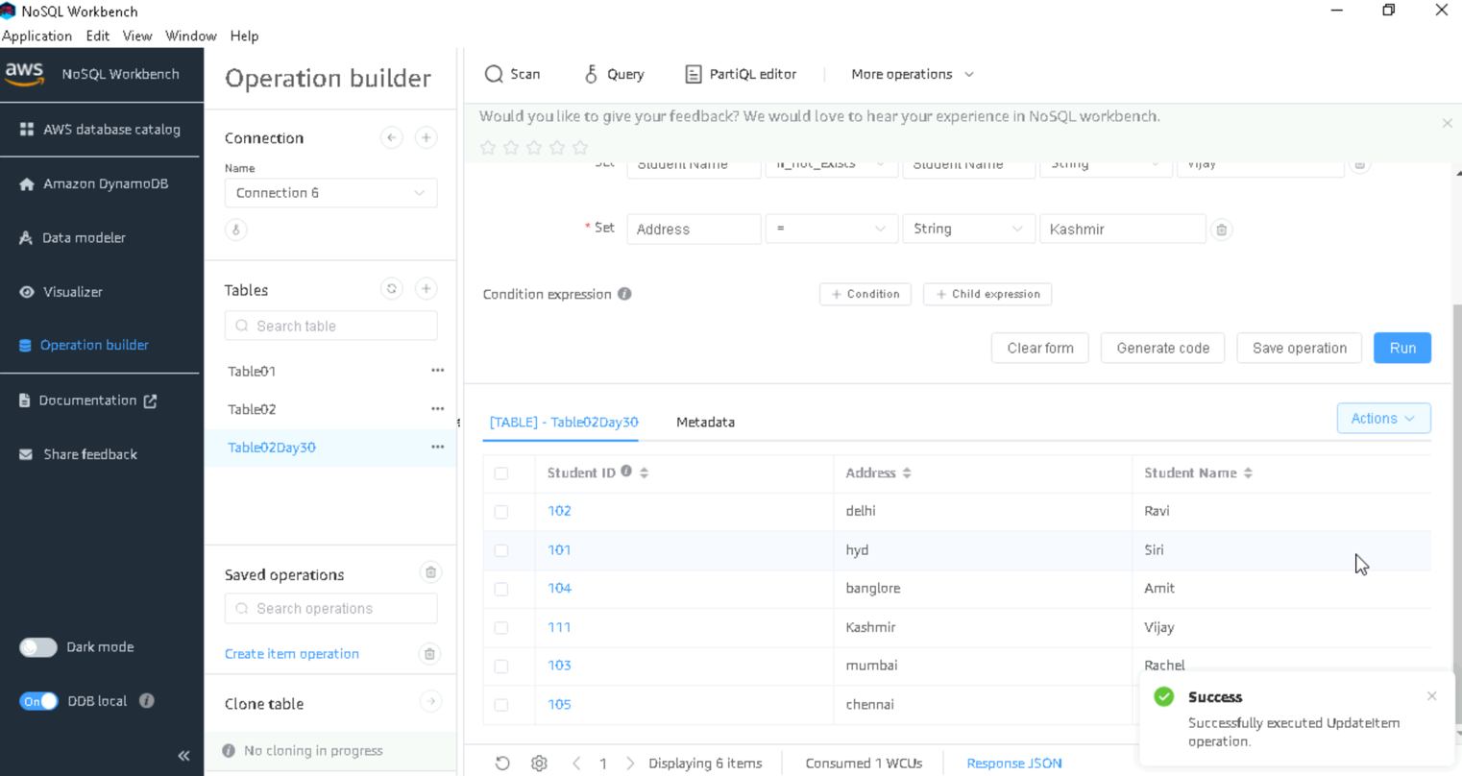

1. Read item with partition key 111

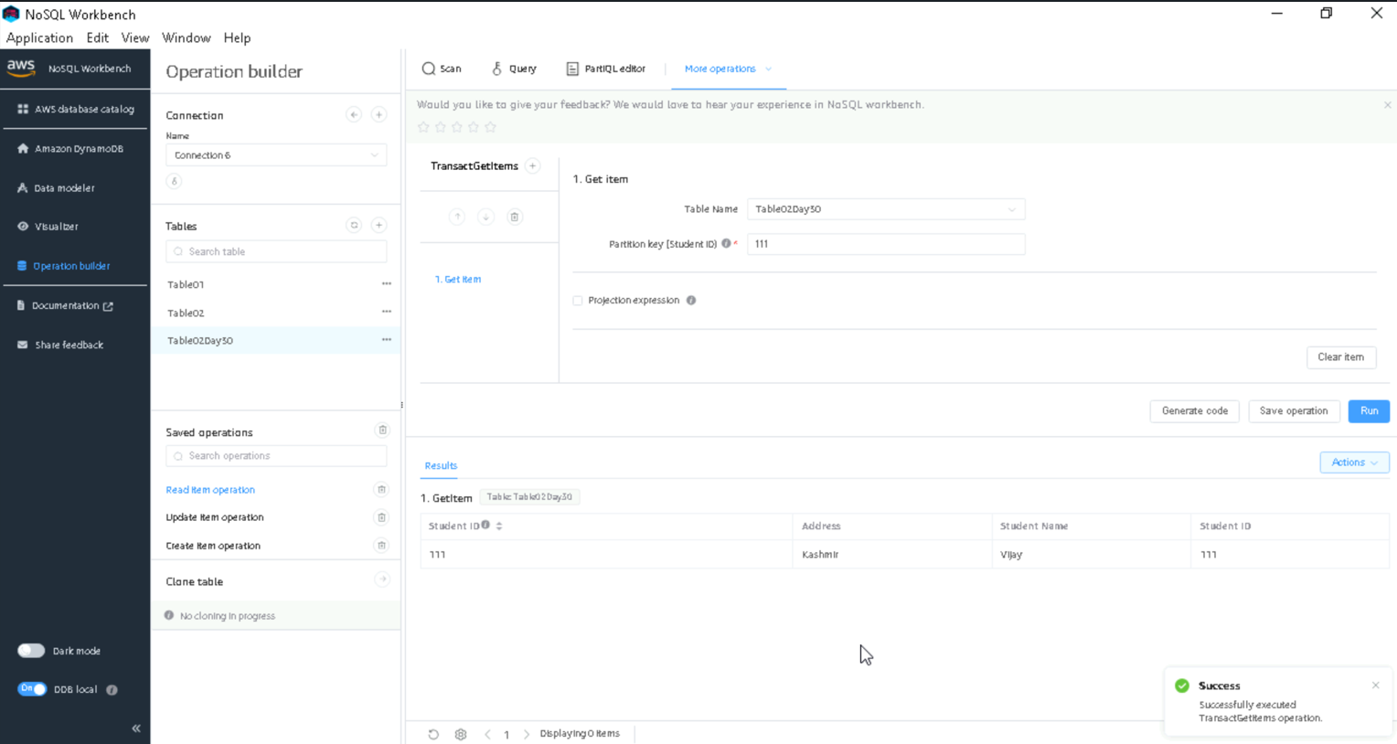

1. Delete item with partititon key 101

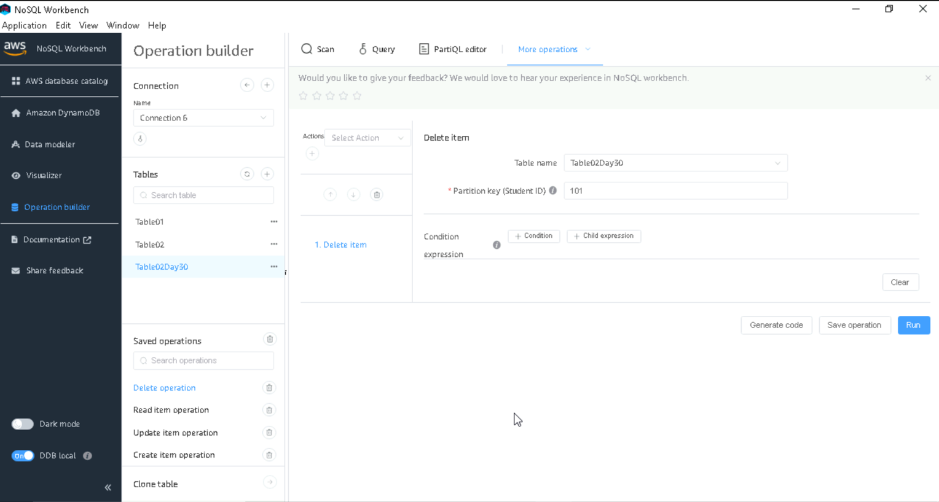

Final table after crud operations

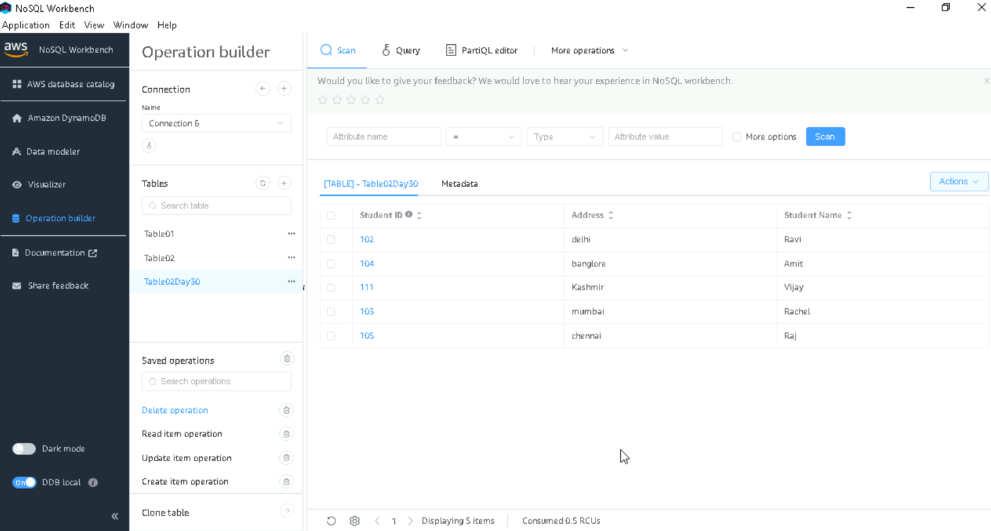

Created a table

aws dynamodb create-table \  
    --table-name EmployeeSpet \  
    --attribute-definitions \  
        AttributeName=EmpName,AttributeType=S \  
        AttributeName=EmpAddress,AttributeType=S \  
    --key-schema \  
        AttributeName=EmpName,KeyType=HASH \  
        AttributeName=EmpAddress,KeyType=RANGE \  
    --provisioned-throughput ReadCapacityUnits=1,WriteCapacityUnits=1

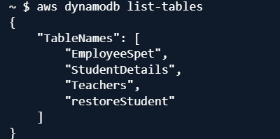

Create items using put-item

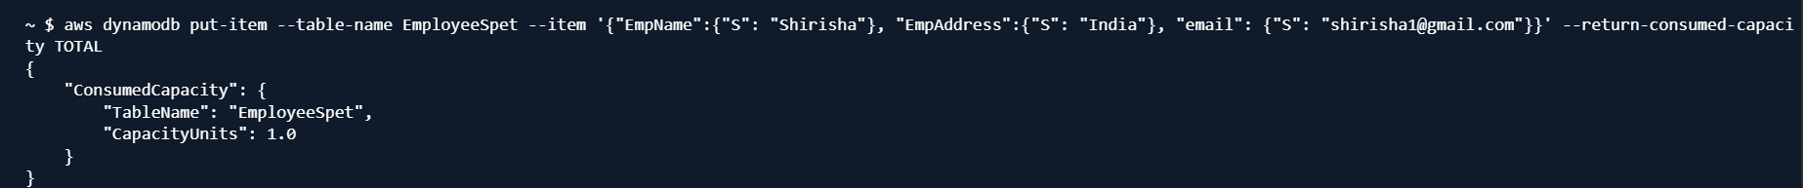

Scan to see

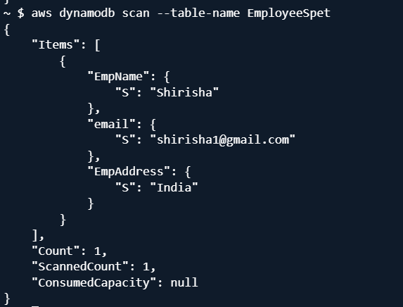

Create a table using wizard

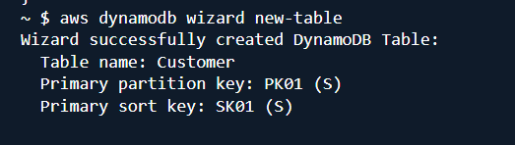

Put item in wizard table Customer

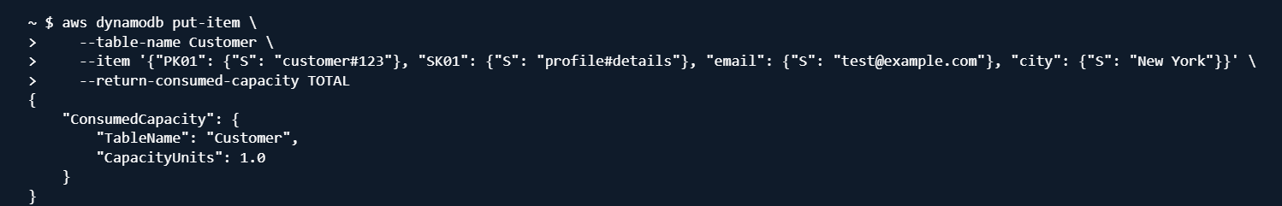

Delete the table Customer

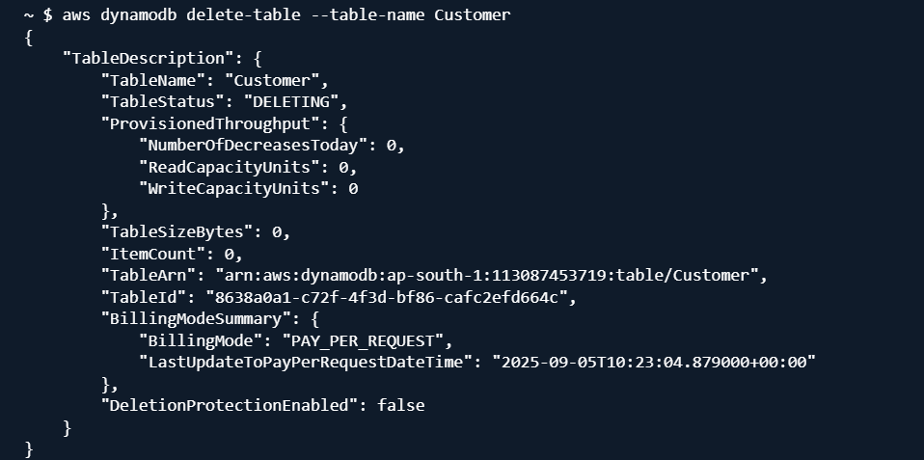

Recheck it by listing all tables.

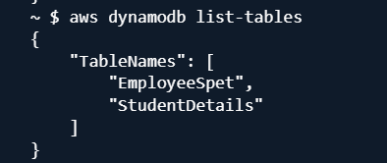

Description of a table

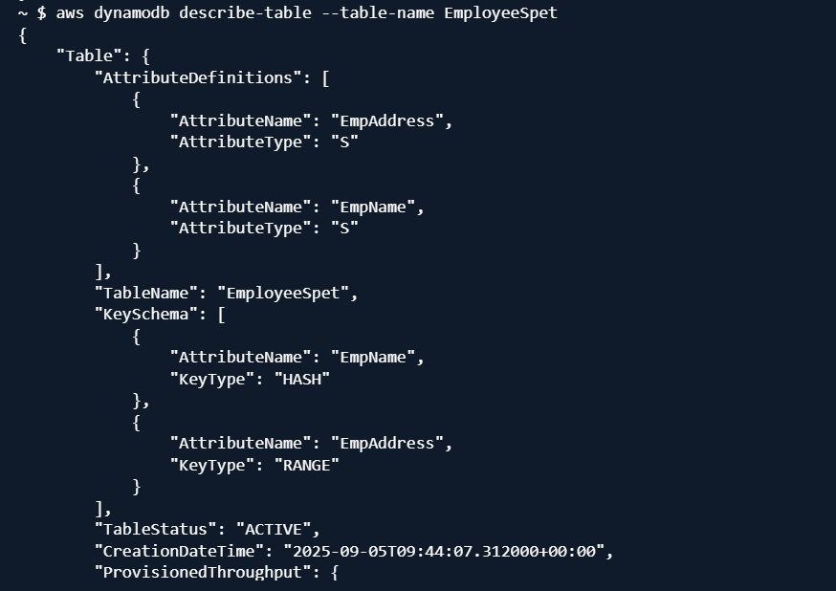

Create a Back up file 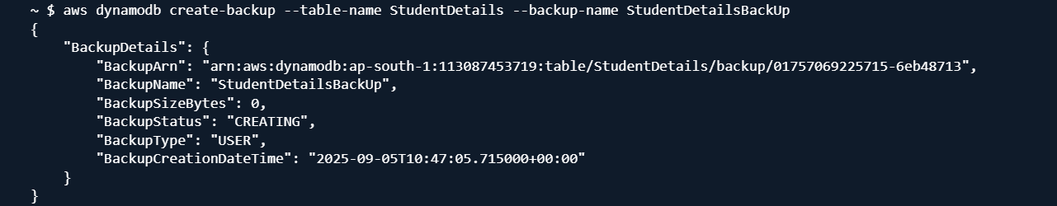

List Backup files

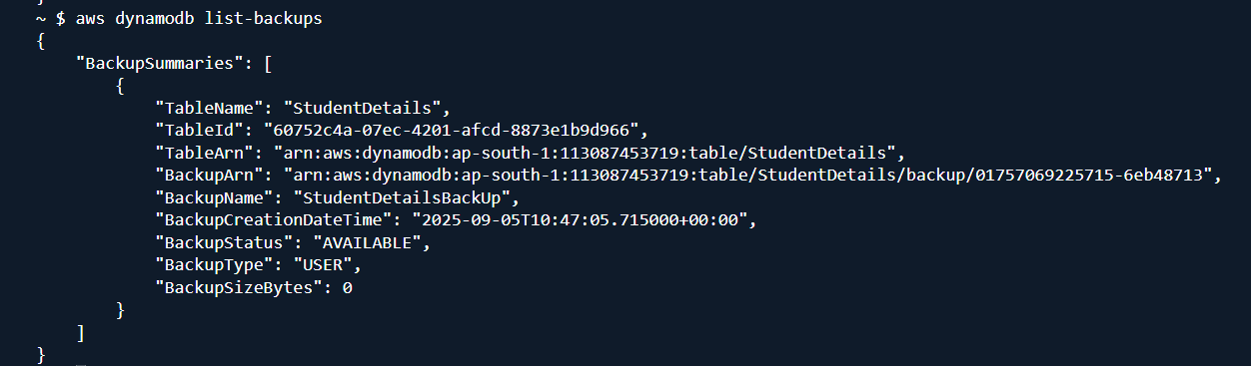

Describe the details of Backup table using BackupArn

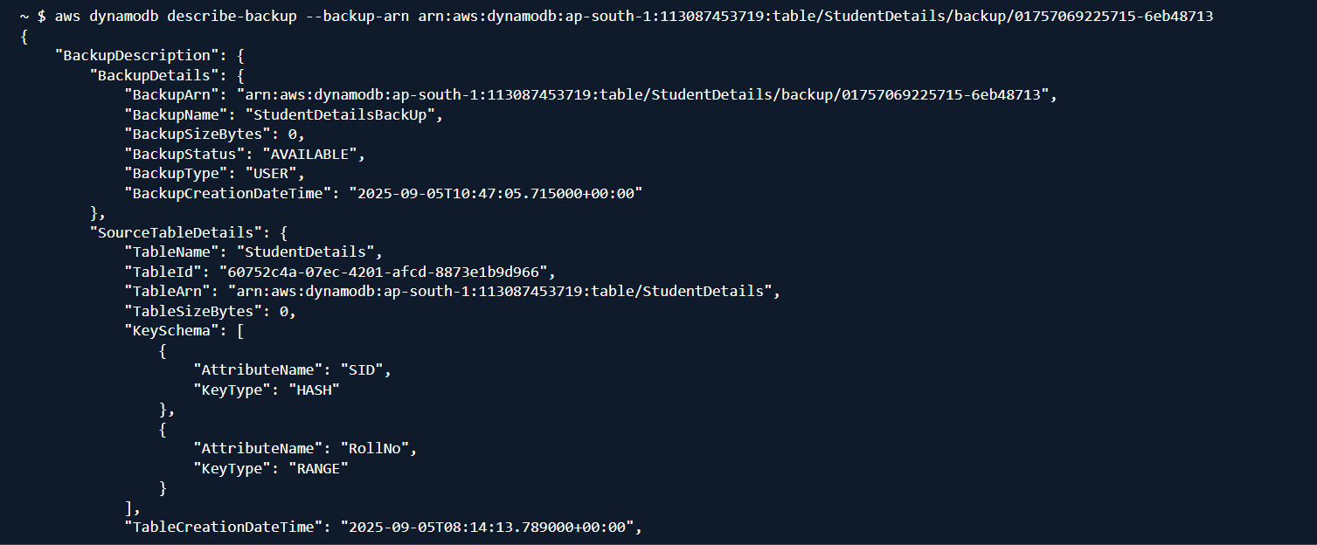

Restore table (restoreStudent) from backup table(StudentDetailsBackup) using backuparn

NOTE: use the aws dynamodb list-backups to get the list of backup tables and from it chose the correct BackupARN

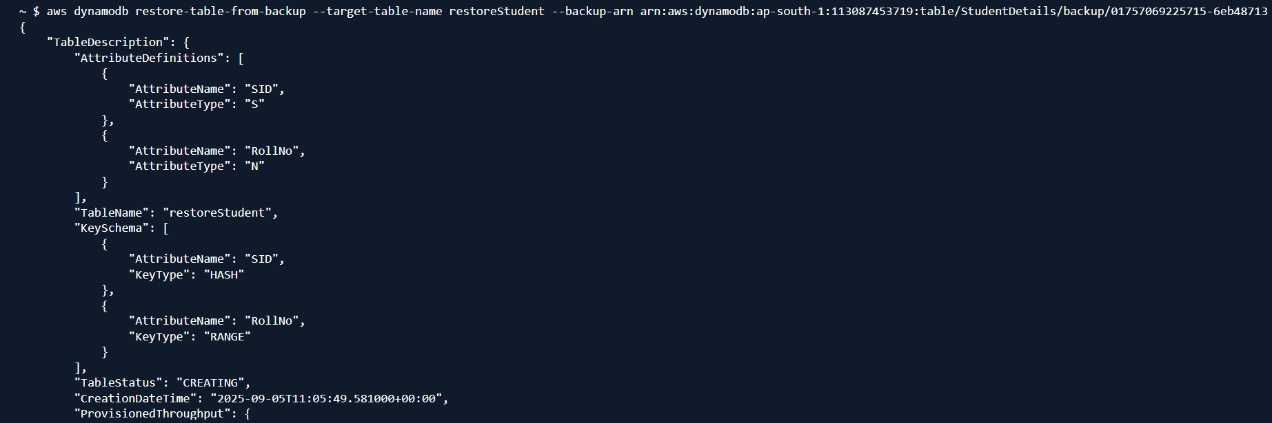

Use scan

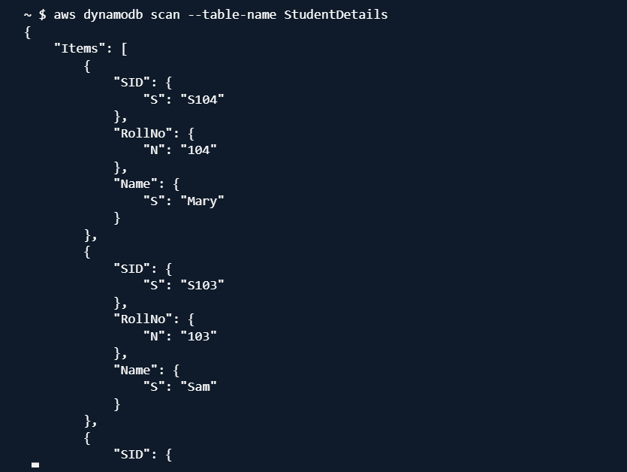

Use get-item for single item

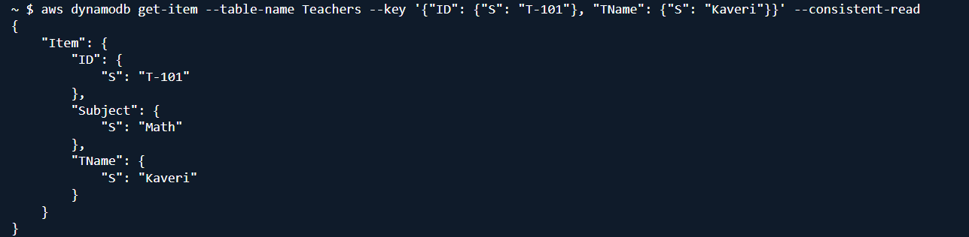

Query for set of items

